Rules:
- Follow directions the first time!

- Come to class prepared (notebook, book, pencil, etc.)!

- Be seated and ready to begin class when the bell rings.

- Ask to go to the bathroom/fountain. You may throw something away/sharpen your pencil. One at a time.

- No foul language or electronics.

- Don’t take others’ belongings, raise your hand to speak, and wait to be called on.

- No cheating or allowing others to cheat off you.

- Return all necessary paperwork signed (if applicable) within the time-frame given (this includes but is not limited to permission slips, grade sheets, documents from a student teacher, etc.).

- Look up class info on our page: http://www.wbasd.k12.pa.us/MrsRicci.aspx. Make up notes from a classmate. Show me your hmwk and make up any missed tests/quizzes (different from originals) within 2 days – otherwise you receive a ZERO. Make up all work during 9th period.

Rewards: Bonus worksheets, time to read, socialize, or computer time. Whoever has the most participation at the end of a quarter wins a prize! Any student who completes all homework at the end of a quarter wins a prize.

Consequences: Warning, writing assignment, detention, phone call home, principal visit, central detention, etc. You will receive a failing grade for cheating. Severe clause: Principal visit.

Procedures:
- At the beginning of class, have your homework out to be checked. You receive full credit if ALL problems are ATTEMPTED.

- After the lesson, students will begin any new homework assignment at the end of class, time-permitting.

- I give fair warning for all quizzes and tests.

- If students need extra help, I am available 9th period. Please let me know if you wish to stay.
Grading procedures: Each quarterly exam is worth 10% of your quarterly average. Homework, tests, quizzes, projects, etc., are worth 90% of your quarterly average. Up to +2 points can be added on to your average for participation. Homework Rule: Students may stay after school to complete a missed homework assignment for partial credit WITHIN TWO DAYS of the initial due date. Homework will count as a large test grade.

Remind App: Remind is a free, safe, and simple messaging tool that help teachers share important updates and reminders with students & parents. Subscribe using the instructions below. Personal information is kept private. Teachers will never see your phone number, nor will you see theirs. Visit remind.com to learn more.

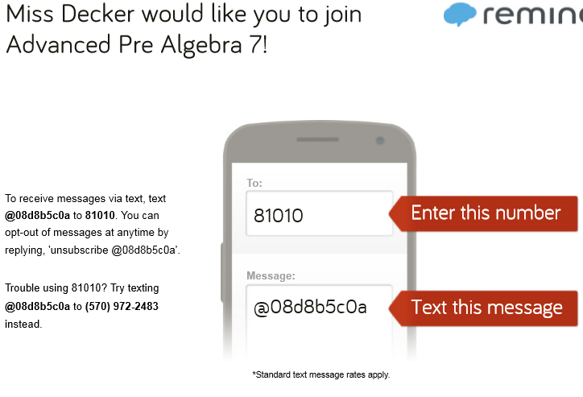

I am looking forward to a successful school year. By all of us working together, a rewarding experience is ahead for all of us. A parent’s role in a child’s education is vital for a child to do well. By you, the parent, knowing about your child’s progress, students will have more of an incentive to do better. If you have any questions or concerns, please contact me at Solomon (570) 826-7224 or via email (preferred) jricci@wbasd.k12.pa.us.

Sincerely,
Mrs. J. Ricci

Mrs. J. Ricci
Math & Computer Science Teacher
Math Club Advisor
Return this page to Mrs. Ricci (will count as a homework assignment).

---------------------------------------------------------------------------------------------------------------------------------------

I, ______________________________, understand all of the rules and procedures and will abide by (print student first and last name)

them accordingly to promote a safe, fun, and learning-filled environment. I am completely

responsible for my actions in the classroom and if I fail to adhere to the rules, I will consequently be

penalized.

Student Signature: ___________________________________________________________________

Parent/Guardian: ___________________________________________________________________

Parent/Guardian:

Please check this box indicating you read the information regarding the VERY useful application, Remind. If students sign up, they receive extra credit. If parents sign up, students receive additional extra credit.

Please check this box indicating you read the handout regarding our class website.

